Day 21
Task 1:
Task 01:

Violation of Liskov

abstract class Bird {
abstract void fly() ;
}
class Eagle extends Bird {
@Override
public void fly() {
sout(" Eagles fly");
}
}
class Ostrich extends Bird {
@Override
public void fly() { // dummy implentation
sout("cant fly high but It lays big egg");
}
}
class Driverclass{
psvm(String[] args){

}
}

- The LSP states that derived classes should be substitutable for their base classes.
- In this case, Ostrich is not a proper substitute for Bird because it can't fly.
- By making Ostrich extend Bird and providing a dummy implementation for fly(), you're violating the LSP.

Task 2: Implementation of Liskov
abstract class BirdsthatFly {
abstract void fly();
}
abstract class BirdsthatDontFly {
abstract void Speciality();
}
class Eagle extends BirdsthatFly {
@Override
public void fly() {
System.out.println("Eagles fly");
}
}
class Ostrich extends BirdsthatDontFly {
@Override
public void Speciality() {
System.out.println("It lays big egg");
}
}
public class Day21_Task2 {
public static void main(String[] args) {
Eagle eagle = new Eagle();
eagle.fly();
Ostrich ostrich = new Ostrich();
ostrich.Speciality();
}
}

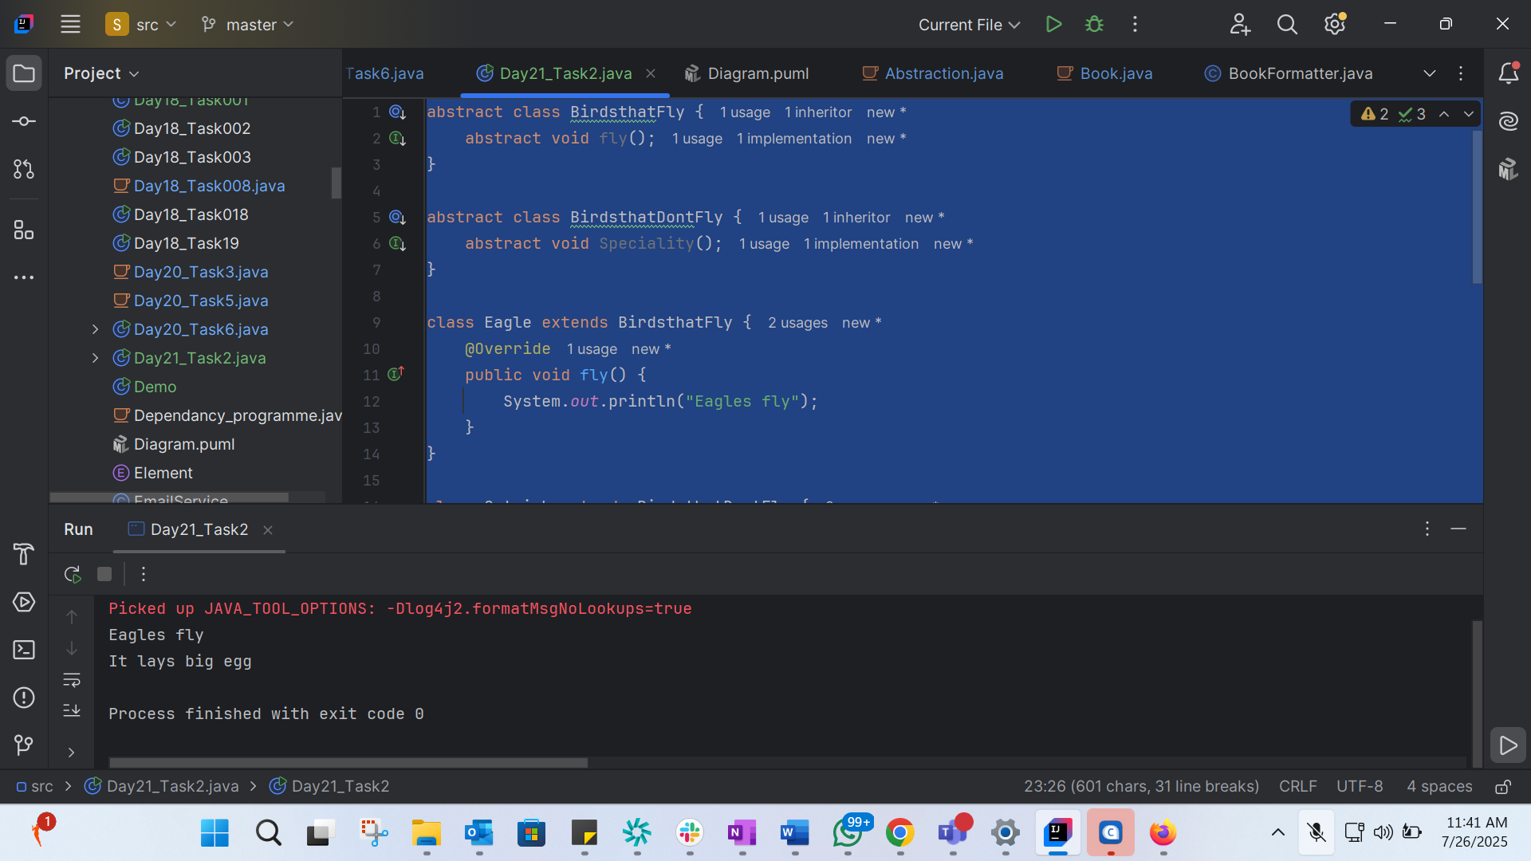

Task 3:
Violation of Interface Segregation principle

interface ICalcShapesArea {
calcArea();
calcVolume();
}
class Circle implements ICalcShapesArea {
calcArea() { sout()};
calcVolume() { sout()}; // dummy implentation as it been forced
}
class Sphere implements ICalcShapesArea {
calcArea() { sout()};
calcVolume() { sout()};
}
class Driverclass {
psvm( ,... ) {
}
}

- The ISP states that clients should not be forced to depend on interfaces they do not use.
- In this case, the Circle class is forced to implement calcVolume() even though it's not relevant to its functionality.
Task 4: Implementation of Interface Segregation Principle
interface ICalcArea {
void calcArea();
void calcPerimeter();
}
interface ICalcVolume {
void calcVolume();
}
class Circle implements ICalcArea {
@Override
public void calcArea() {
System.out.println("Calculating circle area");
}
@Override
public void calcPerimeter() {
System.out.println("Calculating circle perimeter");
}
}
class Sphere implements ICalcArea, ICalcVolume {
@Override
public void calcArea() {
System.out.println("Calculating sphere surface area");
}
@Override
public void calcPerimeter() {
System.out.println("Calculating sphere perimeter (not applicable)");
}
@Override
public void calcVolume() {
System.out.println("Calculating sphere volume");
}
}
public class Day21_Task4 {
public static void main(String[] args) {
Circle circle = new Circle();
circle.calcArea();
circle.calcPerimeter();
Sphere sphere = new Sphere();
sphere.calcArea();
sphere.calcPerimeter();
sphere.calcVolume();
}
}

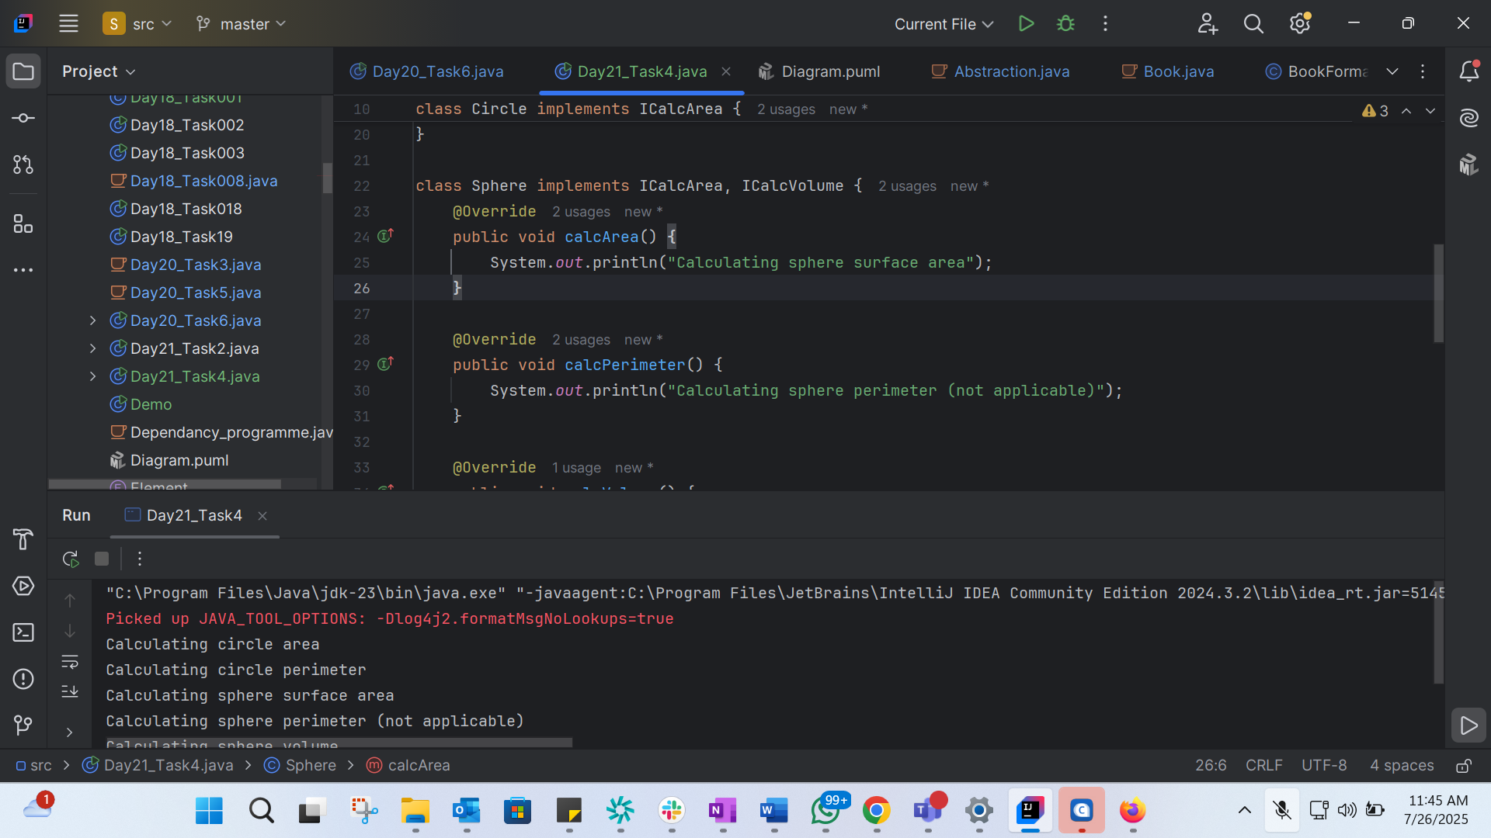
Task 5: lower Bounded Wildcards 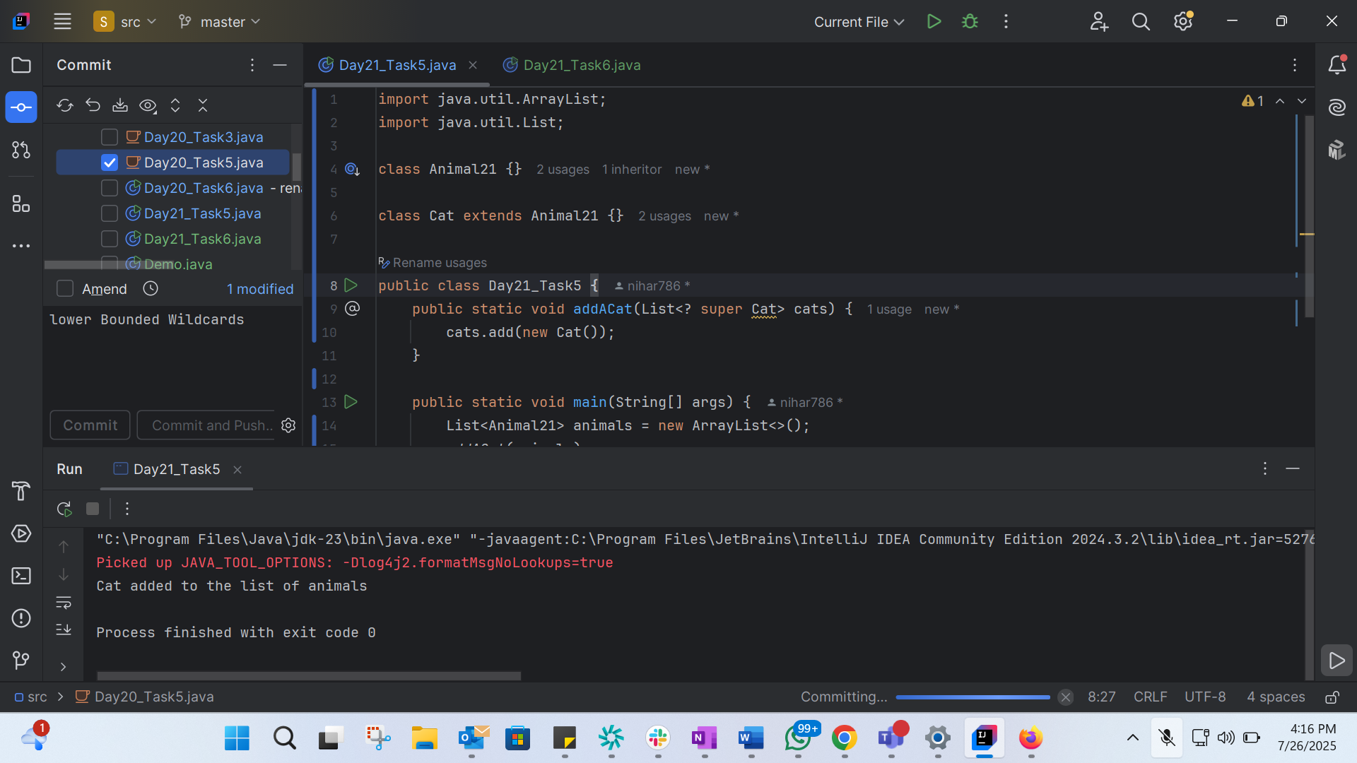
import java.util.ArrayList;
import java.util.List;
class Animal21 {}
class Cat extends Animal21 {}
public class Day21_Task5 {
public static void addACat(List<? super Cat> cats) {
cats.add(new Cat());
}
public static void main(String[] args) {
List<Animal21> animals = new ArrayList<>();
addACat(animals);
System.out.println("Cat added to the list of animals");
}
}

Task 6:Tight coupling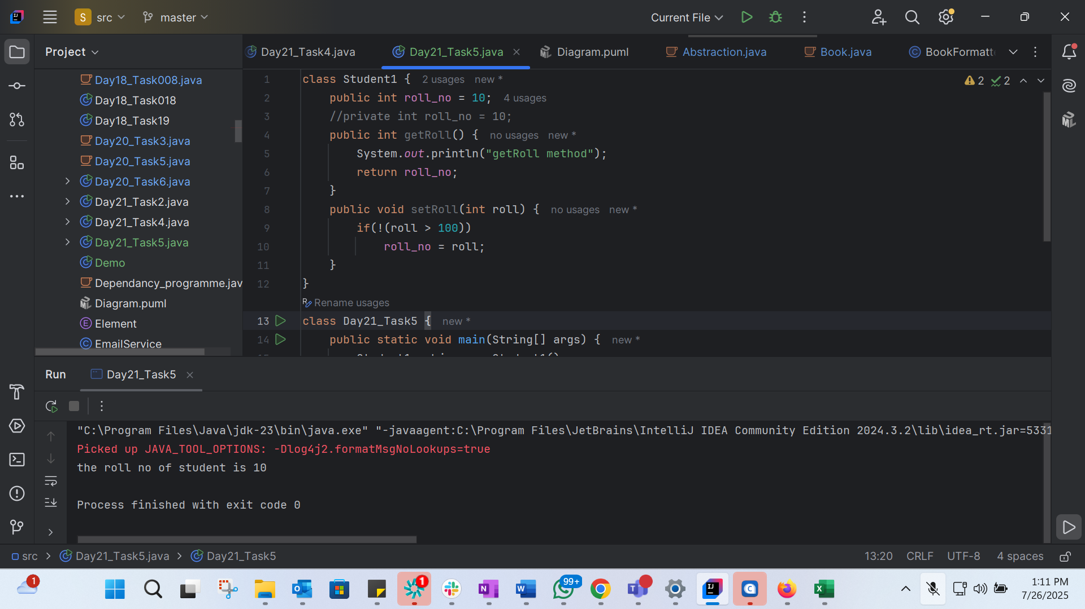
class Student1 {
public int roll_no = 10;
//private int roll_no = 10;
public int getRoll() {
System.out.println("getRoll method");
return roll_no;
}
public void setRoll(int roll) {
if(!(roll > 100))
roll_no = roll;
}
}
class Day21_Task5 {
public static void main(String[] args) {
Student1 sobj = new Student1();
sobj.roll_no = 10;
//sobj.roll_no = 110;
System.out.println("the roll no of student is "+ sobj.roll_no); // 110
}
}

Task 7: loose coupling 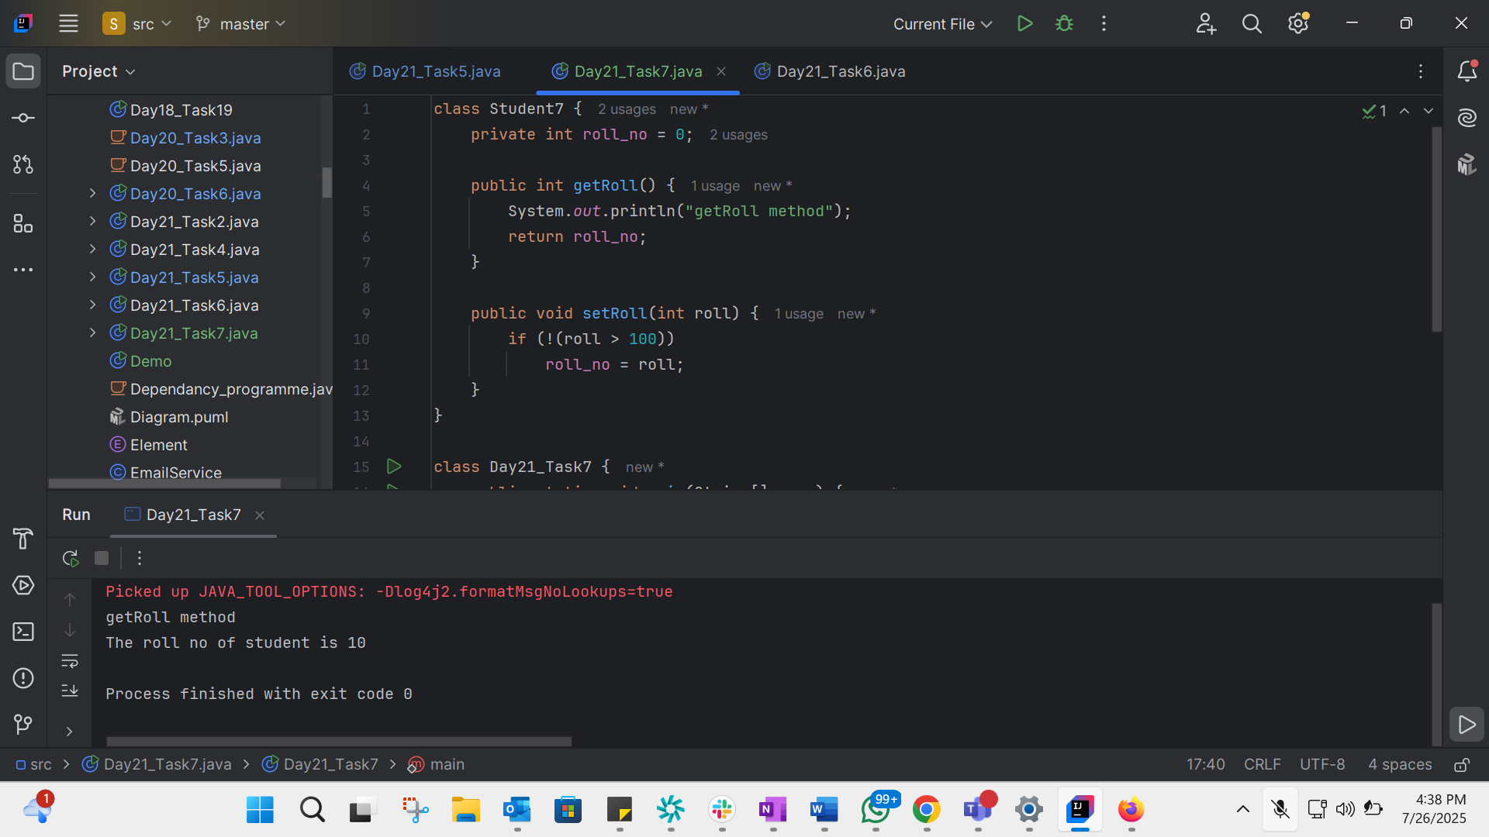
class Student7 {
private int roll_no = 0;
public int getRoll() {
System.out.println("getRoll method");
return roll_no;
}
public void setRoll(int roll) {
if (!(roll > 100))
roll_no = roll;
}
}
class Day21_Task7 {
public static void main(String[] args) {
Student7 sobj = new Student7();
sobj.setRoll(10);
System.out.println("The roll no of student is " + sobj.getRoll());
}
}

Task 8: DIP Violation
class LightBulb {
void turnOn() {
System.out.println("Light turned on");
}
void turnOff() {
System.out.println("Light is off");
}
}
class Day21_Task8 { //switch
LightBulb lbulbobj;
Day21_Task8(LightBulb lbulbobj) {
this.lbulbobj = lbulbobj;
}
void operate() {
lbulbobj.turnOn();
}
public static void main(String[] args) {
LightBulb lbulbobj = new LightBulb();
Day21_Task8 Switchobj = new Day21_Task8(lbulbobj);
Switchobj.operate();
}
}

Task 9: DIP implementation
interface SwitchOnOff {
void turnOn();
void turnOff();
}
class LightBul implements SwitchOnOff {
public void turnOn() {
System.out.println("Light turned on");
}
public void turnOff() {
System.out.println("Light is off");
}
}
class Switch {
SwitchOnOff device;
Switch(SwitchOnOff device) {
this.device = device;
}
void operate() {
device.turnOn();
}
}
public class Day21_Task9 {
public static void main(String[] args) {
SwitchOnOff lbulbobj = new LightBul();
Switch lightswitch = new Switch(lbulbobj);
lightswitch.operate();
}
}

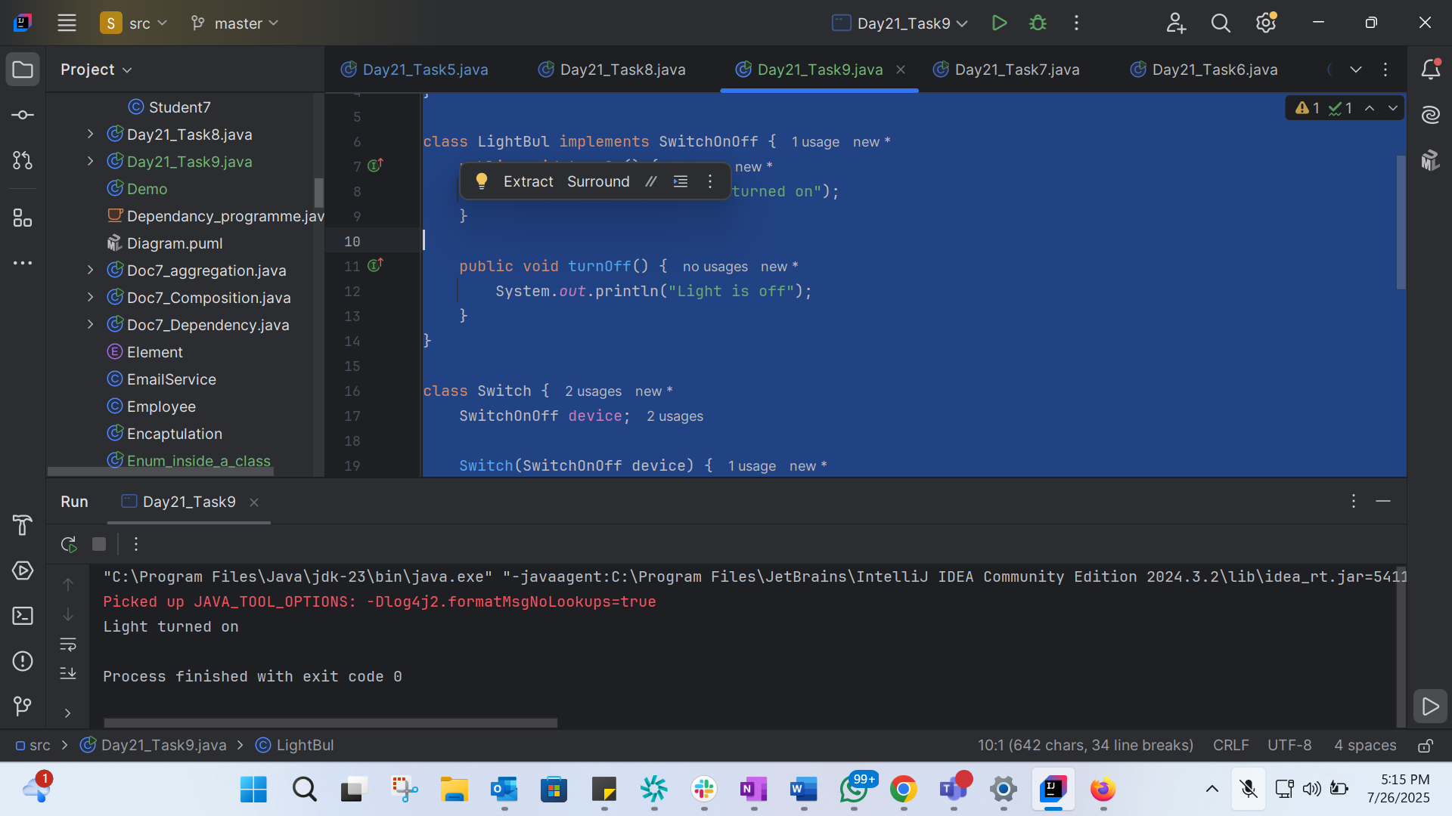

Dependency:
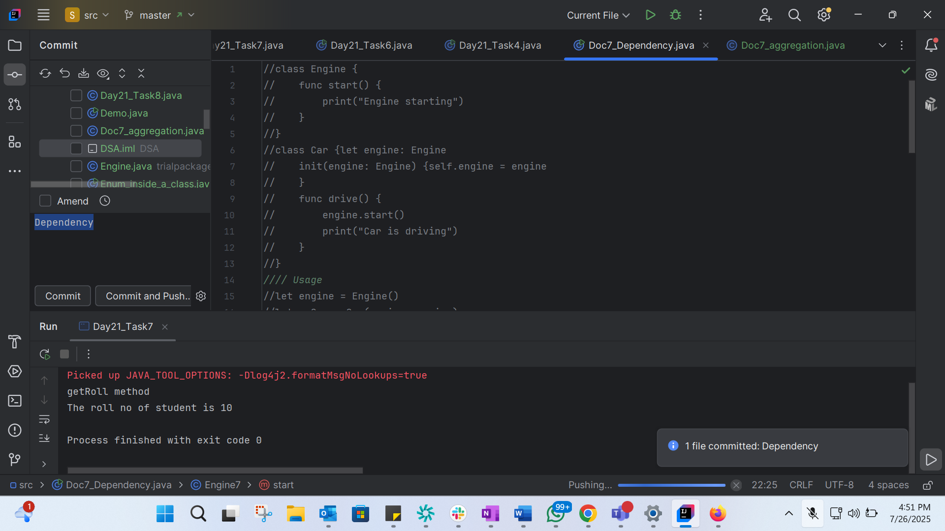
Aggregation:
class Driver {
private String name;
public Driver(String name) {
this.name = name;
}
public String getName() {
return name;
}
}
class CarAgg {
private Driver driver;
public CarAgg(Driver driver) {
this.driver = driver;
}
public Driver getDriver() {
return driver;
}
}
public class Doc7_aggregation {
public static void main(String[] args) {
Driver driver = new Driver("John");
CarAgg myCar = new CarAgg(driver);
}
}
Composition:
class Wheel {
public Wheel() {
System.out.println("Wheel created");
}
}
class Carcom {
private Wheel[] wheels; // Composition
public Carcom() {
this.wheels = new Wheel[] {new Wheel(), new Wheel(), new Wheel(), new Wheel()};
// Wheels are created and owned by Car
}
}
public class Doc7_Composition {
public static void main(String[] args) {
Carcom myCar = new Carcom();
// All wheels created with the car
}
}

